SoluTek

The Jes Foord Foundation Application

Project Plan Document

Version 1.1

15/06/2021

By

**Christopher Millard**

**Juwairya Limalia**

**Joshua Govindsamy**

**Saiyen Govender**

**Azhar Seedat**

Contents

**1. Introduction** 4

1.1 Document purpose 4

1.2 Project Scope 4

1.3 System Goals 4

**2. Positioning** 5

2.1 Problem Description 5

2.2 Problem Solution 5

**3. System Capabilities** 5

**4. Client Benefits** 6

**5. User Environment** 6

**Work Breakdown Structure:** 7

**Project Schedule**: 8

Gantt Chart 8

Company Introduction Meeting (9 April 2021) 8

NGO Identification (12 April 2021) 8

Create a Project Plan (01 June 2021 – 18 June 2021) 8

Create a Requirements Analysis (21 June 2021 – 28 June 2021) 8

Create a Systems Design Documentation (30 June 2021 – 07 July 2021) 8

Develop NGO Solution (7 July 2021 – 20 August 2021) 9

Presentation Preparation (02 September 2021 – 08 September 2021) 9

Presentation (9 September 2021) 9

Finalise System Solution (16 September 2021 – 22 November 2021) 9

Pert Chart: 10

**Risk Management** 11

**Technical feasibility Issues Report** 13

Hardware Resources 13

**Economic Feasibility Issues Report** 14

**Team Members:** 15

Annexure Two: 22

Annexure Three: 23

Annexure Four: 23

Annexure Five: 24

Annexure Six: 25

# **1. Introduction**

## 1.1 Document purpose

The purpose of this document is to capture the overall vision for the Jes Foord Foundation project, this information will help ensure that the project goals are well understood. This document focuses on the needs of the Jes Foord Foundation and the reasons for such needs. This document provides a detailed description of the problem at hand as well as the solution to the problem to give the reader an understanding of the system to be developed. The NGO, VC lecturers as well as the developers of this system will have access to this document. This document will aid in defining boundaries of the system and coming to an agreement on what problems need to be solved.

## 1.2 Project Scope

The JFF software system is a cloud-based data entry solution developed for the intake of census information at each JFF seminar. It allows JFF members to automate manual processes and data tasks. The system will promote efficiency and organization amongst the JFF members.

## 1.3 System Goals

* Make it easier for JFF members to log and organize census information by switching their current manual system to an online software solution.
* Increase the productivity of JFF members.
* Improve the accuracy of census information.

# **2. Positioning**

## 2.1 Problem Description

The Jes Foord Foundation currently uses a manual system for the intake of data at their seminars. Manual systems are vulnerable to physical damage and being misplaced. Manual systems could lead to inaccurate data for numerous reasons such as difficulty in correcting errors and illegible handwriting. Searching through and sorting physical documents is more time-consuming compared to an online system. It is difficult for physical documents to be shared with multiple people at once because a physical document can only be in one location at a time.

## 2.2 Problem Solution

The solution is to digitize the current census intake system. The objective of this software project solution is to increase the productivity and efficiency within the Jes Foord Foundation who support and empower rape survivors and raise awareness. The software solution allows for organized census intake unlike an offline system which can lead to chaos, redundancy, errors and inorganization.

# **3. System Capabilities**

* Users will be able to login and logout; this is to ensure security and confidentiality of information. Security for the system includes authentication, access control, data integrity, and data privacy.
* JFF members will be able to record data at each seminar such as the number of people that attended. The data will be broken down into subcategories such as the number of people who attended for each race group and age range. The system will generate the total and subtotals.
* The system will implement data validation rules and error messages to ensure the correct information is being entered.
* User login details and census information will be stored in a database.

# **4. Client Benefits**

* JFF can decrease their operating expenses by saving money on resources such as paper.
* Editing data will consume less time.
* Easier to backup data; even if a computing device is damaged or lost, the data can still be retrieved from the cloud.
* Reduce the possibility of errors.
* The easy access to data can assist JFF members with better decision-making.
* Reduce the amount of redundant data.
* Less spatial area is needed to store data.
* Data can easily be distributed amongst JFF members and can be examined by multiple people at once.

# **5. User Environment**

* The system compiles and runs on android devices, but with growth it is natural to accommodate other platforms, such as IOS.
* The program will be written in primarily Java and will be interfacing with a real-time database.
* The data will be generated by JFF members and stored server-side.
* All users will be within the same time zone as the one in which the server is located. User locations will be relatively close, in a WAN scenario.

# **Work Breakdown Structure:**

**Please refer to Annexure One for the Work Break down Structure Diagram.**

## **Project Schedule**:

## Gantt Chart

**Please refer to Annexure Two, Three, Four and Five for the visual representation of the Gantt Chart created.**

### Company Introduction Meeting (9 April 2021)

* Members of the team formally met as a company for the first time and assigned a secretary.
* An overview of the given task was conducted.
* Non-profit organisations (NGO/NPO) were discussed to consider who would receive this service.

### NGO Identification (12 April 2021)

* An NGO was decided upon.
* Possible ideas for solutions to provide the NGO were discussed.

### Create a Project Plan (01 June 2021 – 18 June 2021)

* Requirements of what the project plan documentation but successfully explain were discussed.
* Milestones and Deliverables were agreed upon and added to the documentation.
* A Feasibility report was created to provide to provide information on potential threats to the software system’s development.
* A project schedule detailing development hours, milestones and information for a presentation were finalised.
* A work breakdown structure was completed to explain the tasks in greater detail.
* A risk management analysis was created in order to determine appropriate responses to minimise its impact.
* Technical and economic feasibility reports were created to determine the limitations that could occur during development.

### Create a Requirements Analysis (28 June 2021 – 8 July 2021)

* Review the requirements that should be met in terms of what the Requirements Analysis documentation must explain about the solution’s logical structure.
* Identify the functional and non-functional requirements that the solution must complete.
* Create use case diagrams to provide a visual representation of the solution’s use.
* Create and finalise the logical system for accepting, processing and outputting data as well as the relationships between the data and their transitions.

### Create a Systems Design Documentation (16 July 2021 – 28 July 2021)

* The criteria for what the Design Documentation should explain about the solution’s structure and architecture.
* The solution’s architecture to detailed and how it will benefit the solution itself.
* Design concepts for the graphical user interface (GUI) are created.
* Database structure concepts are planned out using the appropriate diagrams to provide information.

### Develop NGO Solution (20 August 2021 – 28 October 2021)

* Final concepts for the GUI are implemented into the solution.
* Input components are implemented into the solution and are configured for accepting input.
* Databases are created for the solution and connected.
* Solution functionalities are developed for interacting with the data.
* User support will be created, in the form of documentation and software assistance that is easily accessed.

### Presentation Preparation (22 November 2021 – 26 November 2021)

* Review and prioritise the information of the solution for the presentation.
* Implement the prototype of the solution for the NGO for use.
* Demonstrate the prototype in a mock-presentation.

### Presentation (December 2021 – Date TBA)

* Demonstrate the prototype at the formal presentation of the solution.
* Allow for Questions and Answers section for the presentation.

### Finalise System Solution (Post-Presentation)

* Team members will each perform a self-evaluation and peer-evaluations.
* The documentation will be edited based on feedback received during the presentation as well as updates for the system solution.
* The solution will undergo debugging and final quality assurance tests before being finalised and published.

## Pert Chart:

PERT Weight Average Calculation Expression: (O + 4M + P)/6

Most Pessimistic Value P

Most Optimistic Value: O

Most Likely Value: M



# **Risk Management**

RATING:

|  |  |  |  |  |
| --- | --- | --- | --- | --- |
| VERY LOW | LOW | MEDIUM (MED) | HIGH | VERY HIGH |

|  |  |  |  |
| --- | --- | --- | --- |
| Risks | Probability | Impact | Risk Control / Mitigation |
| Being Over Budget | LOW | HIGH  - Unintended costs for the client | Proper documentation of finances. Avoiding any contractual obligations (month-month only if necessary). Finding cheaper alternatives to required software. |
| Lack Of Software  Development Support | LOW | HIGH  -Inability to meet deadlines  -Reduced work rate | The workload is divided in terms of proficiency. |
| Server Overload | VERY LOW | VERY HIGH  - Client Dissatisfaction - Compromised data integrity | A scalable service will be used to ensure the optimum throughput is achievable. |
| Unclear Goals For The System | LOW | HIGH  - The potential to not fulfil  desired solution - Wastes time and  resources on development | A clear channel of communication is established with the client to ensure all updates and changes are communicated promptly to determine their overall validity in terms of client appeal. Use case assessments must be  done early in development. |
| Non-User-Friendly System | LOW | HIGH  - Frustrates user  -Can result in the user making unintended errors -Can make the process more tedious than analogue | Colour psychology will be used to design UI elements. Multiple unit tests along with user feedback will reveal potential improvements to the UI before rollout. |
| Being Behind Schedule | MED | MED  – Backlog  - Development becomes  less cost-effective - Client dissatisfaction | Proper planning and continuous assessment of estimated timeframes. |
| Changing Baseline Requirements | HIGH | VERY HIGH   * Can seriously stunt development * New requirements may not be achievable | Proper assessment of use cases to determine the relevancy of the solution proposed. |

# **Technical feasibility Issues Report**

## Hardware Resources

|  |  |
| --- | --- |
| **Resource** | **Available** |
| Laptop or desktop computers | Yes |
| Internet access | Yes |
| Mobile phones | Yes |

All members of the team already have or are able to get access to these hardware resources.

|  |  |
| --- | --- |
| **Resource** | **Available** |
| Github for app storage and version control tools | Yes |
| Microsoft teams for software for online team meetings | Yes |
| Firebase for online cloud databases | Yes |
| Android studio for mobile app development tools | Yes |
| Visual Studio community edition and Visual Studio Code for website app development tools | Yes |
| Microsoft Project for Project management software | Yes |

All of the resources above are easy to access and free to use.

# **Economic Feasibility Issues Report**

The table provided is subject to change, over the period of the development process of the solution, in terms of employee allocation, hourly rates and hours required to reach each milestone of the development progression.

Hourly rates are based on the task each individual is responsible for, as well as current hourly rates for entry-level software engineers in South Africa as of April 2021, averaging from R100 to R250 per hour (The School of IT International, 2021), with the exception of the tasks specified under “Introduction and Identification” and “NGO Identification” as these were meetings held to discuss and plan for the appropriate topics.

Estimated hours for each individual task and each collection of tasks that have been presented in the table are based on the most pessimistic values of hours estimated in the documentation’s PERT chart, in the event of unforeseen delays, time allocations for tasks will be rounded up to the nearest hour, including tasks that have less than an hour allocated to them.

Included in the table are time allocations that apply to the tasks, and collective time allocations where there is more than one team member assigned to the task where employees will work either parallel to one another on the task or on the same task but in individual sections, demonstrated in figure 1 and figure 2, as an estimate at the current time of writing this documentation.

**Team Members Working Parallel**

|  |  |  |
| --- | --- | --- |
| Task | Team Member #1 | 3 hrs |
| Team Member #2 |
| Team Member #3 |

Figure 1: Working Parallel

**Team Members Working Individually for the Same Task**

|  |  |  |
| --- | --- | --- |
| Task | Team Member #1 | 1 hr |
| Team Member #2 | 2 hrs |
| Team Member #3 | 1 hr |

Figure 2: Working Individually

**Please refer to Annexure Six for the Economic Feasibility Table.**

# **Team Members:**

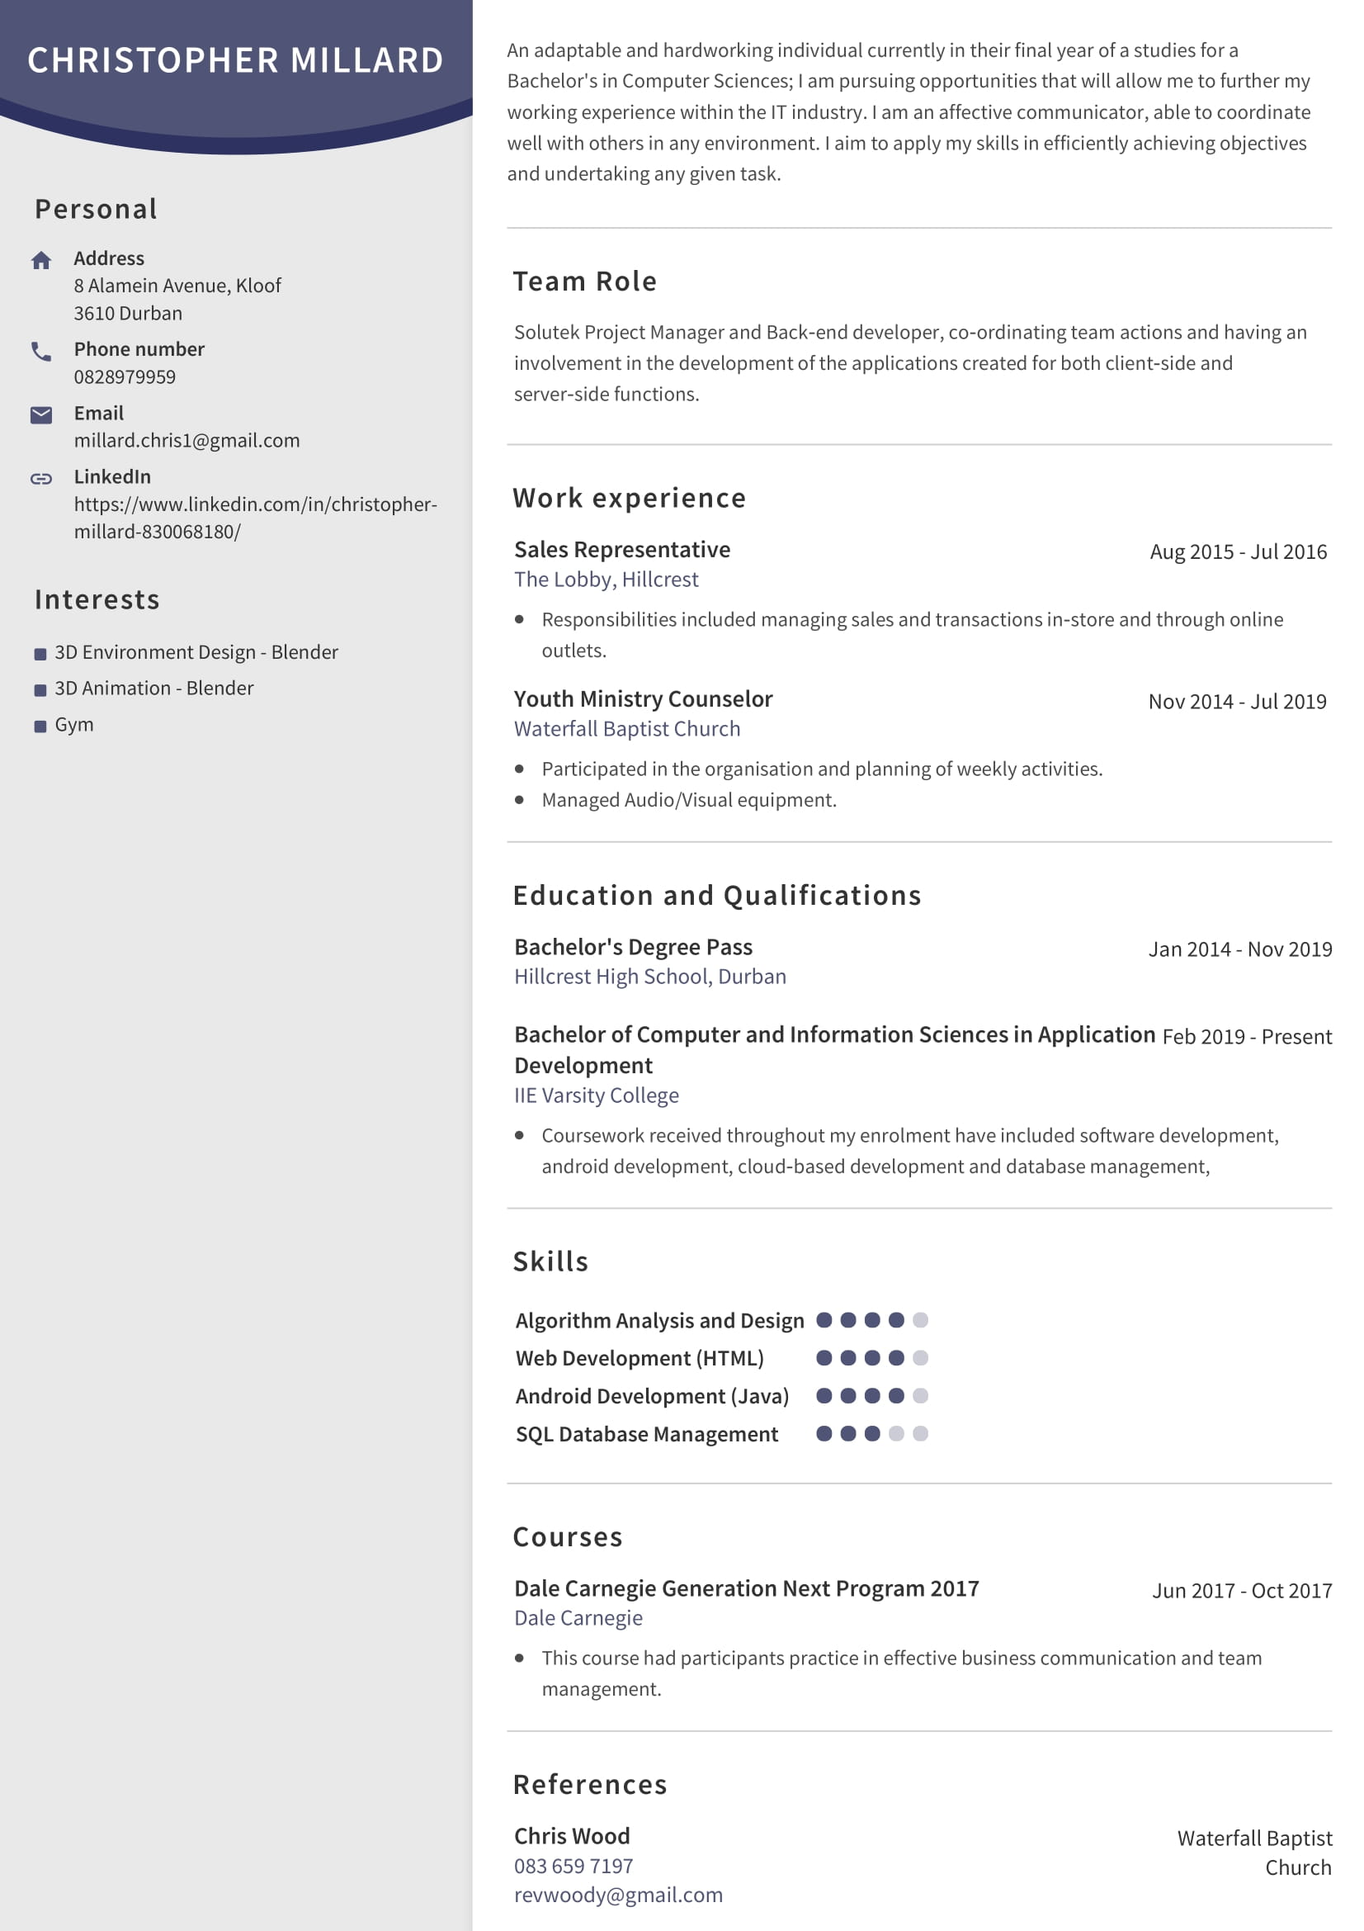

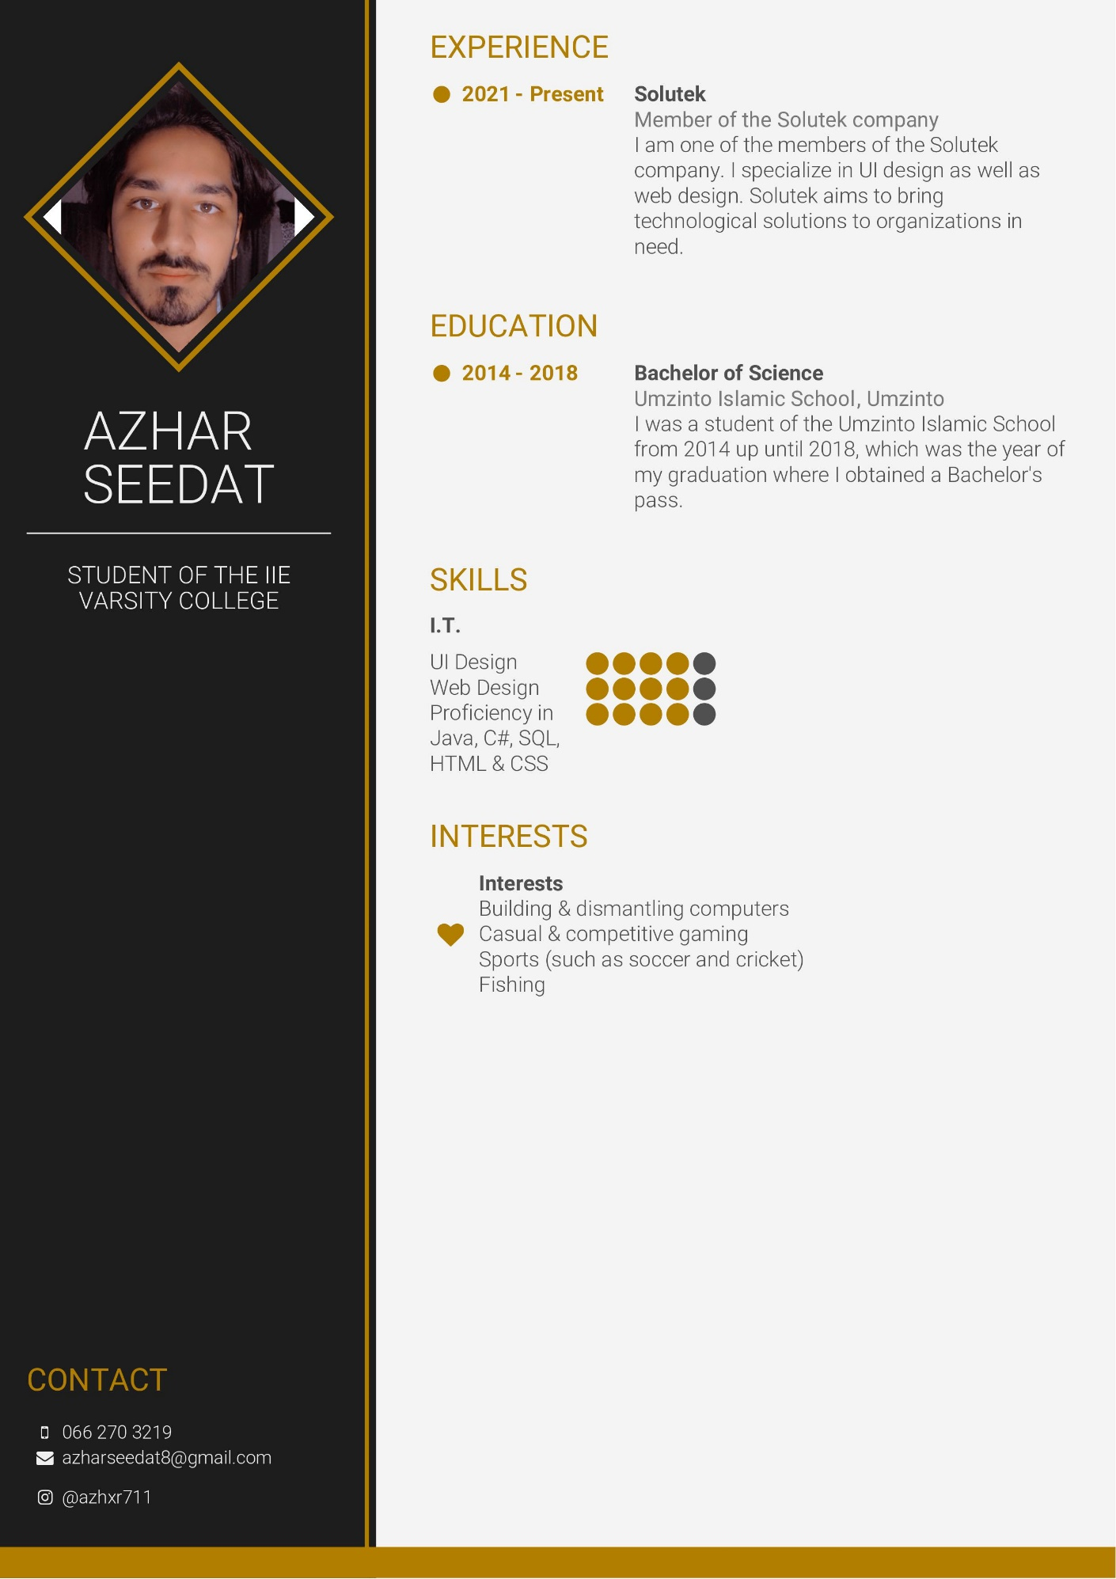

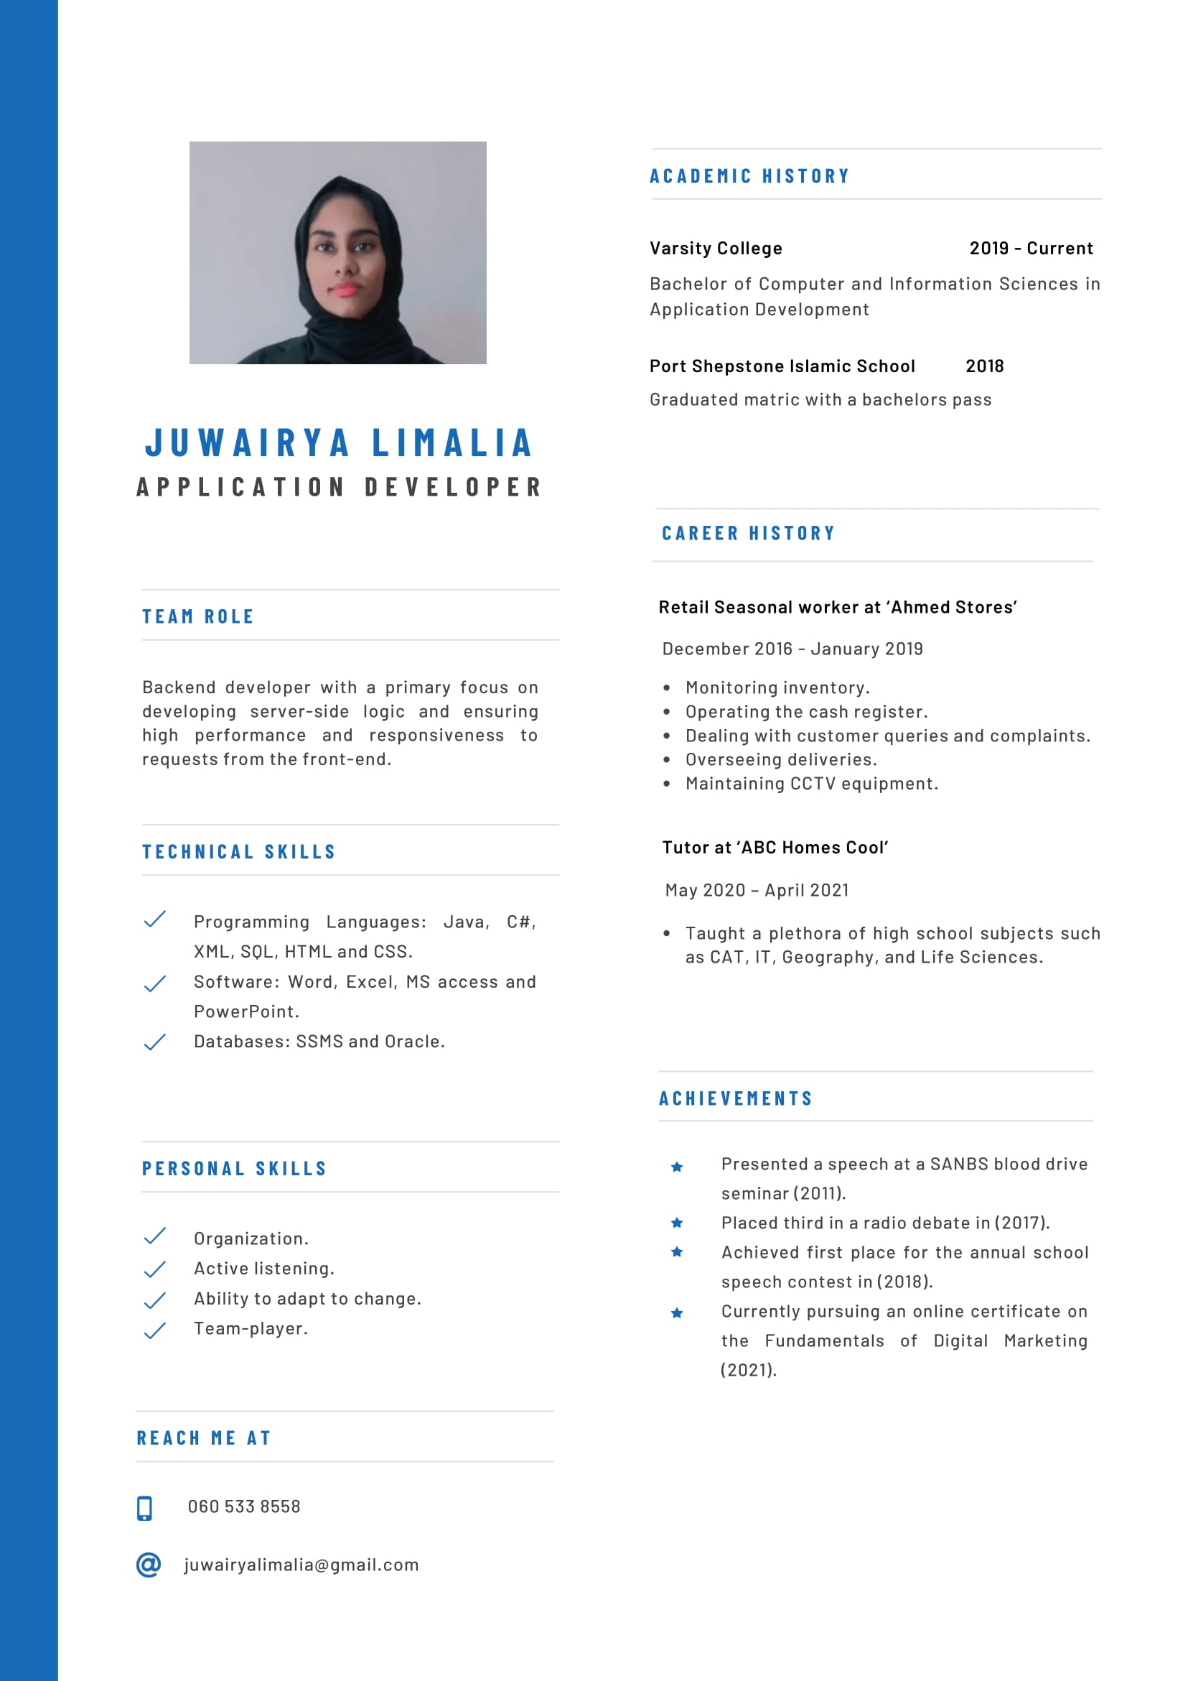

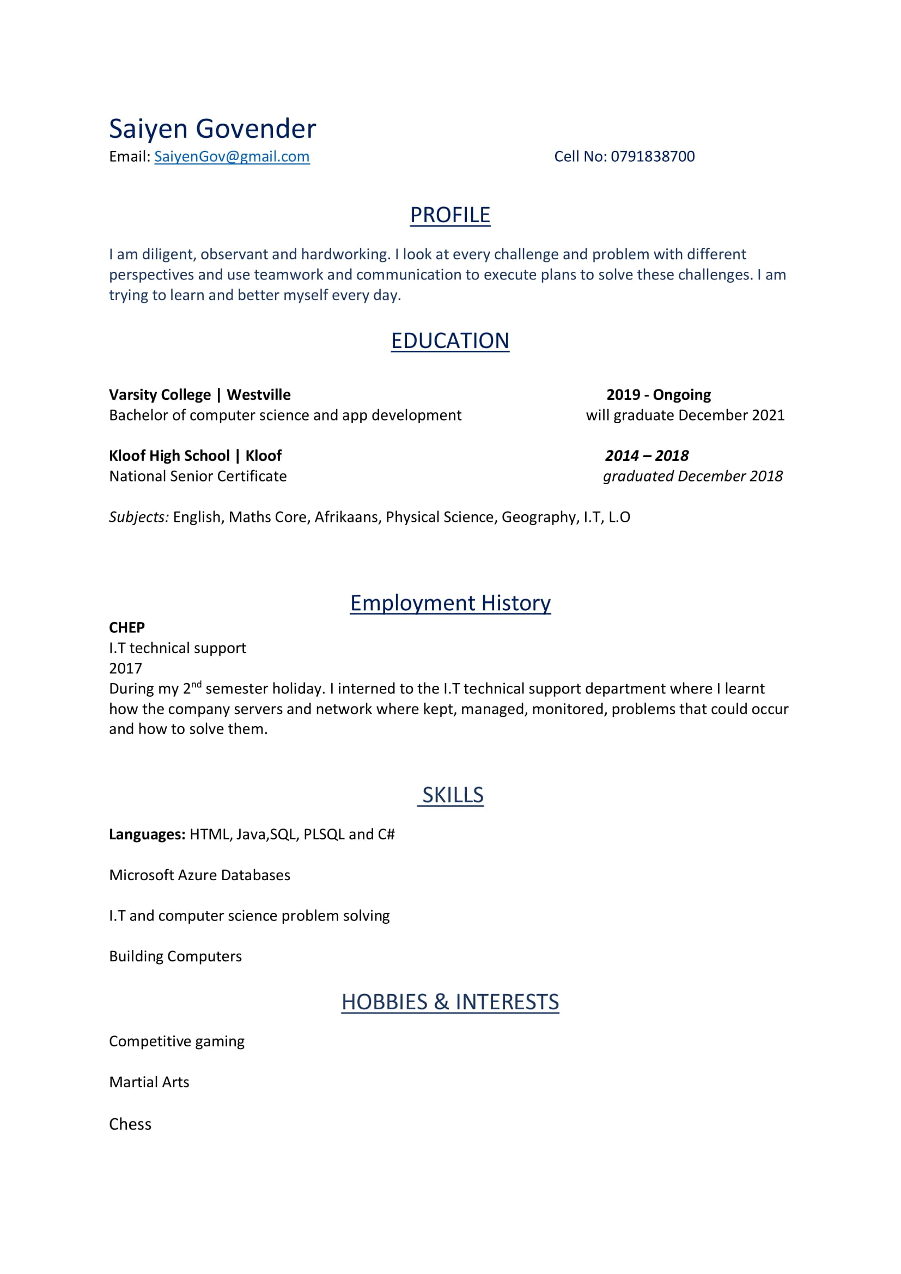



Annexure One: 

# Annexure Two:



# Annexure Three:



# Annexure Four:



# Annexure Five:



# Annexure Six:

|  |  |  |  |  |
| --- | --- | --- | --- | --- |
| Details | | Cost Estimates | | |
| Task: | **Team Member(s):** | **Hours:** | **Hourly Rate:** | **Total:** |
| Introductions and Identification | **All** | **1** |  |  |
| Review Given Task | Chris | 0.5 hrs  (~30 minutes) |  |  |
| Juwairya |  |  |
| Saiyen |  |  |
| Joshua |  |  |
| Azhar |  |  |
| Discuss Potential NGOs | Chris | 0.5 hrs  (~30 minutes) | R100/hr | R100.00 |
| Juwairya | R100/hr | R100.00 |
| Saiyen | R100/hr | R100.00 |
| Joshua | R100/hr | R100.00 |
| Azhar | R100/hr | R100.00 |
| NGO Identification | **All** | **1 hr** |  |  |
| Confirm NGO | Chris | 0.5 hrs  (~30 minutes) |  |  |
| Juwairya |  |  |
| Saiyen |  |  |
| Joshua |  |  |
| Azhar |  |  |
| Discuss Potential Solutions | Chris | 0.5 hrs  (~30 minutes) | R100/hr | R100.00 |
| Juwairya | R100/hr | R100.00 |
| Saiyen | R100/hr | R100.00 |
| Joshua | R100/hr | R100.00 |
| Azhar | R100/hr | R100.00 |
| Create Project Plan | **All** | **5 hrs** |  |  |
| Review Project Plan Components | Chris | 0.5 hrs  (~30 minutes) | R100/hr | R100.00 |
| Juwairya | R100/hr | R100.00 |
| Saiyen | R100/hr | R100.00 |
| Joshua | R100/hr | R100.00 |
| Azhar | R100/hr | R100.00 |
| Identify Milestones and Deliverables | Juwairya | 0.5 hrs  (~30 minutes) | R120/hr | R120.00 |
| Create a Feasibility Report | Juwairya | 1 hr | R120/hr | R120.00 |
| Saiyen | R120/hr | R120.00 |
| Chris | R120/hr | R120.00 |
| Create Project Schedule | Chris | 0.5 hrs  (~30 minutes) | R120/hr | R120.00 |
| Create Work Breakdown Structure | Azhar | 0.5 hrs  (~30 minutes) | R120/hr | R120.00 |
| Create a Risk Management Analysis | Joshua | 1 hr | R120/hr | R120.00 |
| Azhar | R120/hr | R120.00 |
| Juwairya | R120/hr | R120.00 |
| Create Technical and Economic Feasibility Reports | Saiyen | 0.5 hrs | R120/hr | R120.00 |
| Chris | 0.5 hrs | R120/hr | R120.00 |
| Create a Requirements Analysis | **All** | **5 hrs** |  |  |
| Review Analysis Criteria | Chris | 0.5 hrs  (~30 minutes) | R100/hr | R100.00 |
| Juwairya | R100/hr | R100.00 |
| Saiyen | R100/hr | R100.00 |
| Joshua | R100/hr | R100.00 |
| Azhar | R100/hr | R100.00 |
| Identify Functional Requirements | Chris | 1 hr | R120/hr | R120.00 |
| Joshua | R120/hr | R120.00 |
| Develop Use Case Diagrams | Azhar | 1 hr | R140/hr | R140.00 |
| Develop a Logical System | Saiyen | 2 hrs | R130/hr | R260.00 |
| Juwairya | R130/hr | R260.00 |
| Create a Systems Design Documentation | **All** | **5 hrs** |  |  |
| Review System Design Criteria | Chris | 0.5 hrs  (~30 minutes) | R100/hr | R100.00 |
| Juwairya | R100/hr | R100.00 |
| Saiyen | R100/hr | R100.00 |
| Joshua | R100/hr | R100.00 |
| Azhar | R100/hr | R100.00 |
| Design Application Architecture | Juwairya | 1.5 hrs  (~90 minutes) | R125/hr | R250.00 |
| Chris | R125/hr | R250.00 |
| Design Solution GUI Concept | Joshua | 1.5 hrs  (~90 minutes) | R125/hr | R250.00 |
| Azhar | R125/hr | R250.00 |
| Design Database Concept | Saiyen | 1 hr | R180/hr | R180.00 |
| Develop NGO Solution | **All** | **16 hrs** |  |  |
| Review Final Concepts | Chris | 1 hr | R100/hr | R100.00 |
| Juwairya | R100/hr | R100.00 |
| Saiyen | R100/hr | R100.00 |
| Joshua | R100/hr | R100.00 |
| Azhar | R100/hr | R100.00 |
| Design Graphical User Interface | Joshua | 2 hrs | R170/hr | R340.00 |
| Azhar | R170/hr | R340.00 |
| Create and Populate Database | Saiyen | 2 hrs | R170/hr | R340.00 |
| Develop Data Input Components | Juwairya | 1.5 hrs | R170/hr | R340.00 |
| Saiyen | 1.5 hrs | R170/hr | R340.00 |
| Azhar | 1.5 hrs | R170/hr | R340.00 |
| Develop Application Functions | Chris | 3 hrs | R170/hr | R510.00 |
| Juwairya | 3 hrs | R170/hr | R510.00 |
| Develop User Support | Azhar | 2.5 hrs | R140/hr | R350.00 |
| Joshua | R140/hr | R350.00 |
| Presentation Preparation | **All** | **3 hrs** |  |  |
| Review Presentation Criteria | Chris | 0.5 hrs  (~30 minutes) | R100/hr | R100.00 |
| Juwairya | R100/hr | R100.00 |
| Saiyen | R100/hr | R100.00 |
| Joshua | R100/hr | R100.00 |
| Azhar | R100/hr | R100.00 |
| Implement Solution Prototype |  | 0.5 hrs  (~30 minutes) |  |  |
| Mock Presentation | Chris | 1 hr | R100/hr | R100.00 |
| Juwairya | R100/hr | R100.00 |
| Saiyen | R100/hr | R100.00 |
| Joshua | R100/hr | R100.00 |
| Azhar | R100/hr | R100.00 |
| Presentation | Chris | **1 hr** | R100/hr | R100.00 |
| Juwairya | R100/hr | R100.00 |
| Saiyen | R100/hr | R100.00 |
| Joshua | R100/hr | R100.00 |
| Azhar | R100/hr | R100.00 |
| Finalise System and Application | **All** | **3 hrs** |  |  |
| Self-Evaluation Tasks | Chris | 0.5 hrs  (~30 minutes) | R100/hr | R100.00 |
| Juwairya | R100/hr | R100.00 |
| Saiyen | R100/hr | R100.00 |
| Joshua | R100/hr | R100.00 |
| Azhar | R100/hr | R100.00 |
| Implement Recommendations from Feedback | Joshua (GUI) | 1.5 hrs  (~90 minutes) | R150/hr | R300.00 |
| Azhar (GUI) | R150/hr | R300.00 |
| Saiyen (Database) | 1.5 hrs  (~90 minutes) | R150/hr | R300.00 |
| Juwairya (Functionality) | 2 hrs | R150/hr | R300.00 |
| Chris (Functionality) | R150/hr | R300.00 |
| Debug and Finalise | Joshua (GUI) | 1.5 hrs  (~90 minutes) | R160/hr | R320.00 |
| Azhar (GUI) | R160/hr | R320.00 |
| Saiyen (Database) | 1.5 hrs  (~90 minutes) | R160/hr | R320.00 |
| Juwairya (Functionality) | 2 hrs | R160/hr | R320.00 |
| Chris (Functionality) | R160/hr | R320.00 |
| Final Submission | **All** | **1 hr** |  |  |
| Demonstrate Final Implementation | Chris | 0.5 hrs  (~30 minutes) | R100/hr | R100.00 |
| Juwairya | R100/hr | R100.00 |
| Saiyen | R100/hr | R100.00 |
| Joshua | R100/hr | R100.00 |
| Azhar | R100/hr | R100.00 |
| Submit Documentation and Software | Chris | 0.5 hrs  (~30 minutes) | R100/hr | R100.00 |
| Juwairya | R100/hr | R100.00 |
| Saiyen | R100/hr | R100.00 |
| Joshua | R100/hr | R100.00 |
| Azhar | R100/hr | R100.00 |
| Total Wages: |  | | | R16260.00 |